Q1. Given five

memory partitions of 100Kb, 500Kb, 200Kb, 300Kb, 600Kb (in order),

how would the first-fit, best-fit, and worst-fit algorithms place

processes of 212 Kb, 417 Kb, 112 Kb, and 426 Kb (in order)? Which algorithm makes the most efficient use of memory?

First-fit:

212K is put in 500K partition = 500-212=

417K is put in 600K partition = 600-417=

112K is put in 200K partition

426K must wait

Best-fit:

212K is put in 300K partition = 300-212=

417K is put in 500K partition = 500-417=

112K is put in 200K partition

426K is put in 600K partition

Worst-fit:

212K is put in 600K partition =600-212

417K is put in 500K partition

112K is put in 300K partition

426K must wait

Q2. Consider the segment table 2.

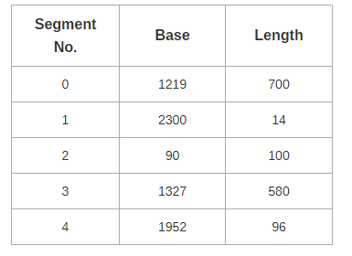

Which of the following logical address will produce trap addressing error?

1. 0, 430
2. 1, 11
3. 2, 100
4. 3, 425
5. 4, 95

Ans: No trap

|  |  |  |  |  |
| --- | --- | --- | --- | --- |
| **Segment #** | **Base** | **Limit** | **Base + Limit** | **Base + Logical** |
| 0 | 1219 | 700 | 1219+700=1919 | 1219+430=1649 |
| 1 | 2300 | 14 | 2300+14=2314 | 2300+11=2311 |
| 2 | 90 | 100 | 90+100=190 | 90+100=190 |
| 3 | 1327 | 580 | 1327+580=1907 | 1327+425=1752 |
| 4 | 1952 | 96 | 1952+96=2048 | 1952+95=2047 |

If (Base+Logical) is > (Base+Limit), then it is a trap.